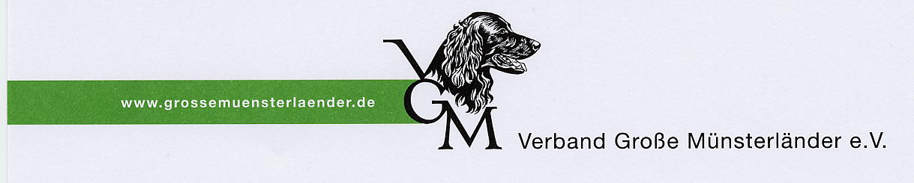
Verband Große Münsterländer e.V.
Zuchtbuchamt Wurfabnahmerückmeldung
Herrn Winfried Wardemann mit Chipnummer und Welpenerwerber
Büskesheide 7
Zwingername:____________________________________
46499 Hamminkeln Züchter:_________________________________________

Zuchtwartbestätigung: Datum____________ Unterschrift:_______________________________________
-
ChipNr.: einkleben  1______________________________  2______________________________  3______________________________  4______________________________  5______________________________  6______________________________  7______________________________  8______________________________  9______________________________  10_____________________________  11_____________________________ | ZBNr.:  ________  ________  ________  ________  ________  ________  ________  ________  ________  ________  ________ | Rufname  __________  __________  __________  __________  __________  __________  __________  __________  __________  __________  __________ | Erwerber  _________________________________  _________________________________________  _________________________________________  _________________________________________  _________________________________________  _________________________________________  _________________________________________  _________________________________________  _________________________________________  _________________________________________  _________________________________________  _________________________________________  _________________________________________  _________________________________________  _________________________________________  _________________________________________  _________________________________________  _________________________________________  _________________________________________ _________________________________________  _________________________________________  _________________________________________
Bitte so bald wie möglich an das Zuchtbuchamt zurück

